
-
Alert Level: Investigating and Preventing Food Contamination Problem in Bangladesh using AI



AMERICAN INTERNATIONAL UNIVERSITY–BANGLADESH (AIUB)
FALL 2023-24
BUSINESS COMMUNICATION [FST/FE] [H]
REPORT
Alert Level: Investigating and Preventing Food Contamination Problem in Bangladesh using AI

Submitted by

NAME | ID | CONTRIBUTION
Khushbu Alam Rahi | 22-46947-1 | Abstract & Result
Sadikuzzaman Rakib | 22-46971-1 | Methodology & Result
MD Eaoumoon Haque | 22-47526-2 | Recommendation
Sharfin Ahmed Shanto | 22-49561-3 | Introduction & Conclusion

Abstract— The main purpose of the report was to investigate and prevent food contamination problem in Bangladesh using AI. A survey was conducted on 70 students currently studying at American International University-Bangladesh. This survey was hosted on Google form by preparing a questionnaire and the link was sent through teams to the students. Single choice and multiple choices were used in the survey. The result illustrated that 36.1% of students ate restaurant or street food 2-3 times a week and 39.3% students got stomach ache occasionally after eating outside food. The least number of students consulted with doctor after having food poisoning which is 2.5% approximately. The researcher recommended implementing technology and AI based app “Foodies” for detecting and preventing contaminated food.
Alert Level: Investigating and Preventing Food Contamination Problem in Bangladesh using AI
Haque Eaoumoon, Sadikuzzaman Rakib, Khushbu Alam Rahi, Sharfin Ahmed

.

Index Terms— Food Contamination, Survey, Questions, Students, AI, Technology.

INTRODUCTION
Every year, millions of people get poisoned from food and many die. Food safety as a concern was first brought up by the great German scientist “Friedrich Accum [1]. He composed a book, “A treatise on Adulteration of Food and Culinary Poisons” in 1820, stating the unscrupulous details of food processing practices in London [1]. Salter, 2014, reports that the US Centre for Disease Control and Prevention confirmed over 11,000 foodborne infections in 2013 [2]. These illnesses are caused by harmful living things like bacteria, viruses, and parasites that contaminate food during production. Callejon et al., 2015, identify various agents like viruses, bacteria, toxins, parasites, metals, and other chemicals as causes of food contamination [2]. For a long time, people have been trying to keep food safe, but new technology is giving us even better ways to do it.
This report highlights innovative solutions that could help us to fight against food contamination. We're going to look at some cool ideas to make food safer. By using color changing method to check if the food is still good. We’ll also check out how blockchain tech can track and show where our food comes from.
This report intends to demonstrate:
1.What are the main reasons behind food contamination?
2.Why is predicting food issues with technology helpful?
3.What are the steps using AI to prevent food contamination?
Since population keeps increasing and it is expected to reach 10 billion by 2050, it's very important to make sure we have enough safe and healthy food for everyone. Using these new technologies to keep our food safe is a great way to make sure we reach this goal and keep people healthy. That is why we are proposing “Foodie” as a solution which will help people detect adulteration in food. It is like taking a path that leads to a healthier and more sustainable environment where we can enjoy meals without worrying about the potential risks. These new ways not only make our food safer but also help create a better world where communities are strong and can bounce back from challenges.

Ⅱ.Methodology
A survey was conducted to students at the American International University of Bangladesh, focusing on their awareness of contaminated food in Bangladesh. The survey aimed to explore students' knowledge about contaminated food, the extent of their consumption, and the sources from which they obtain such food. Additionally, participants were asked to identify any problems they faced because of consuming contaminated food. The questionnaire, comprising a total of 15 questions, utilized Google Forms for data collection. The questions included a mix of single-choice and multiple-choice formats. Approximately 70 students voluntarily participated in the survey, and no personal information was collected during the process.

Ⅲ.Results
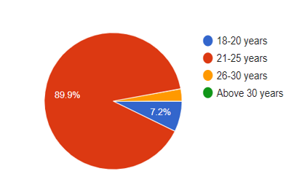
Fig 1: Participant Ages
Figure 1 shows the percentage of the age of the participants of this survey. Most of the participants of this survey have ages between 21 and 25 and they constitute about 89.9 % of Fig. 1. The second-largest group of participants has an age between 18 and 20 and they cover about 7.2%. The rest of the people are around the age of 26 to 30.

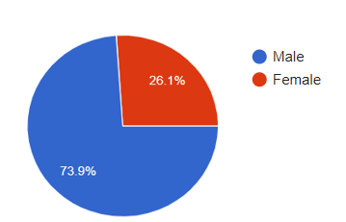

Fig 2: Participant Gender

Figure 2 tries to figure out the percentage of the gender of the participants of this survey. About 73.9% of people are male among the participants. The rest of the people are female.

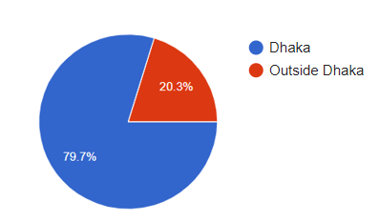
Fig 3: Geographic Distribution of Participants

Figure 3 demonstrates the percentage of the participants area. Most of the people faced the problem inside Dhaka which is about 79.7%. Some of the people faced the problem outside Dhaka.

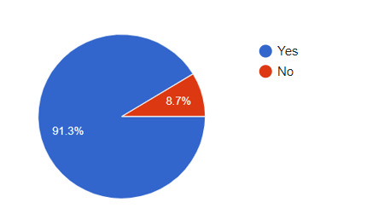
Fig 4: Participants' Awareness of Food Contamination

Figure 4 tries to figure out the percentage of awareness participants of this survey. Most of the participants of this survey are aware of food contamination. And only 8.7% of participants are not aware of food contamination.

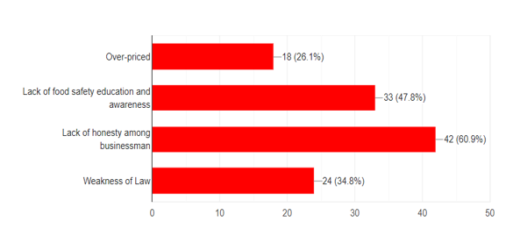

Fig. 5: Factors in Food Contamination
The graph represents the responses to a question about the main reasons behind food contamination. The data is categorized into four factors: Over-priced (26.1%, 18 responses), Lack of food safety education and awareness (47.8%, 33 responses), Lack of honesty among businessmen (60.9%, 42 responses), and Weakness of Law (34.8%, 24 responses). The percentages indicate the proportion of respondents who identified each factor as a significant reason for food contamination. The data suggests that the majority of respondents believe that the Weakness of Law and Lack of honesty among businessmen are the most prominent reasons for food contamination, while Over-priced and Lack of food safety education and awareness are considered to be less significant factors.

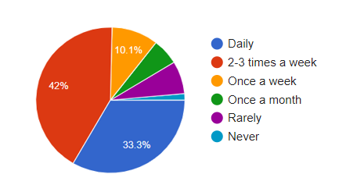

Fig. 6: Consumer Purchases: Processed Food Frequency
The graph illustrates the purchasing frequency of packaged/processed food products by respondents or their families. The majority of respondents make these purchases 2-3 times a week, constituting 42% of the responses. Daily purchases follow closely at 33.3%. Other frequencies include once a week (10.1%), once a month (5.8%), rarely (7.2%), and never (1.4%). The most notable percentage is the high frequency of 2-3 times a week.

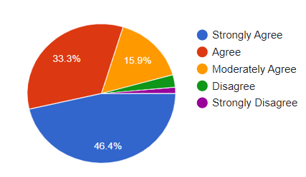

Fig. 7: Consumer Purchases: Processed Food Frequency

The graph depicts respondents beliefs regarding the extent of adulteration in the majority of market food items. The highest percentage is under "Strongly Agree" at 46.4%, followed by "Agree" at 33.3%. "Moderately Agree" represents 15.9%, while "Disagree" and "Strongly Disagree" constitute 2.9% and 1.4%, respectively. The notable difference lies in the considerable gap between "Strongly Agree" and the other response categories, indicating a prevalent belief in a significant degree of adulteration in market food items.

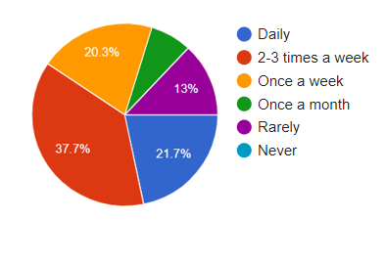

Fig. 8: Dining Habits: Outside Food Frequency

The graph displays the frequency of respondent’s consumption of outside (restaurant or street) food. Notably, 37.7% of respondents indulge in such food 2-3 times a week, making it the most common frequency. Daily consumption follows at 21.7%, and once a week is reported by 20.3% of participants. On the lower end, once a month represents 7.2%, while rarely and never account for 13% and 21.7%, respectively. The significant difference lies in the higher percentages for 2-3 times a week and daily consumption, indicating a prevalent trend of frequenting outside food establishments.

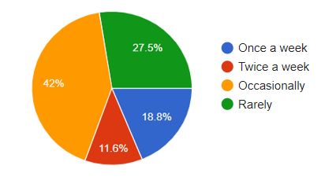

Fig. 9: Health Impact: Discomfort from Outside Food
The graph tries to find the frequency of experiencing stomachaches after consuming food outside. The most prevalent response is occasionally at 42%, indicating a frequent but not consistent occurrence. Rarely follows at 27.5%, while once a week and twice a week represent 18.8% and 11.6%, respectively. The notable difference lies in the considerable percentage under Occasionally, suggesting that stomach discomfort is a common, though not constant, occurrence for a significant portion of respondents.

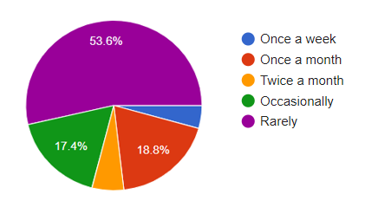

Fig. 10: Healthcare Trends: Doctor Visits for Food Poisoning

The graph outlines the frequency of doctor visits due to food poisoning incidents. The majority of respondents, at 53.6%, rarely seek medical attention for food poisoning. "Once a month" accounts for 18.8%, while "Occasionally" represents 17.4%. The most significant difference is in the high percentage of respondents who rarely visit a doctor for food poisoning, highlighting a common tendency to manage such incidents without seeking professional medical assistance.

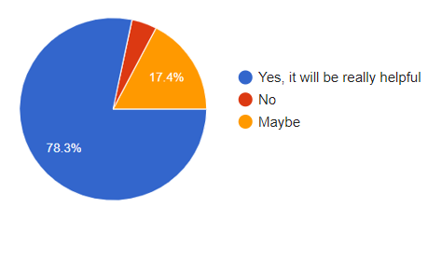

Fig.11 : Tech Appetite: Food Contamination App Interest
This Fig. 11 reflects respondents willingness to use a food contamination detection app. A significant majority, at 78.3%, express a strong interest, citing it as potentially highly helpful. In contrast, a small percentage, 4.3%, outright reject the idea, while 17.4% remain undecided, expressing a possibility of using the app. The notable difference lies in the overwhelming positive response, suggesting a strong inclination towards adopting a food contamination detection app among the majority of respondents.

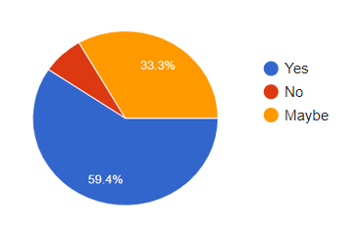
Fig. 12: Perception Understanding: Impact on Threat
Reduction

The graph shows respondents perspectives on the potential impact of detecting food contamination. A significant majority, 59.4%, believe that detection will decrease the threat of food contamination. A smaller percentage, 7.2%, holds a contrary opinion, while 33.3% are uncertain, expressing a possibility that detection might mitigate the threat. The significant difference lies in the substantial majority affirming the belief in the efficacy of detecting food contamination for reducing associated threats.
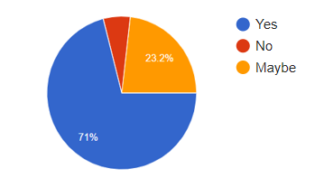
Fig.13:Public Perception:Impact of Food Contamination Detection on Awareness
Fig. 13 displays respondents opinions on whether detecting food contamination will enhance awareness among the public and authorities. A substantial majority, at 71%, believes that detection will contribute to increased awareness. In contrast, a small percentage, 5.8%, disagrees with this notion, while 23.2% are uncertain, expressing a possibility that detection might impact awareness. The significant difference lies in the strong consensus among respondents who foresee heightened awareness through the detection of food contamination.

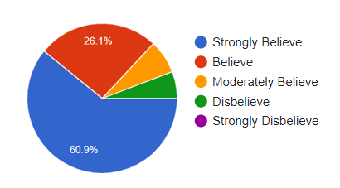

Fig. 14: Safety Advocacy: Stricter Food Regulations

Figure 14 tries to demonstrate how respondents beliefs regarding the necessity of stricter laws and regulations to enhance food safety in their region. A significant majority, at 60.9%, strongly believes in the need for stricter measures. Additionally, 26.1% express a general belief in the necessity, while 7.2% moderately believe in it. A small percentage, 5.8%, disagrees with the idea, and there are no respondents who strongly disbelieve. The major difference lies in the substantial percentage of respondents strongly supporting the idea of implementing stricter laws and regulations for improving food safety.

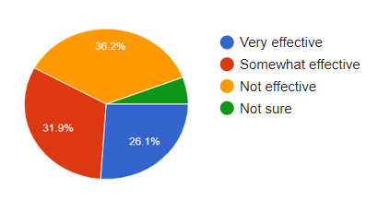

Fig. 15: Effectiveness Assessment: Current Food Safety Regulations

Figure 15 tries to determine respondents beliefs about the effectiveness of current food safety regulations. Notably, 26.1% perceive them as very effective, while 31.9% consider them somewhat effective. A substantial portion, 36.2%, expresses the view that these regulations are not effective. Additionally, 5.8% are unsure about their effectiveness. The major difference lies in the significant percentage of respondents who are skeptical about the effectiveness of

Ⅳ.Recommendation
In recent years machine learning has made our lives a lot easier. “In just the last five or 10 years, machine learning has become a critical way, arguably the most important way, most parts of AI are done,” said MIT Sloan professor Thomas W. Malone, the founding director of the MIT Center for Collective Intelligence. In this proposed app people can combat food adulteration to some extent. There are already few apps in the play store like’ Yuka-Food and Cosmetic scan” and “open Food Facts” etc. But in this app which we are proposing as “Foodie” there will be some extra features like a variety of food can be checked such as liquid, beans, rice, meats, vegetables, fruits etc.

Everyone has mobile phones nowadays so they can easily take photos of their food and look it up in the app. Various information will be used in this app from research [3] [4] already done on detection of food contaminations. Spectral and Spectral Imaging Techniques, Computer vision System (CVS) and many other techniques were used in the 1st mentioned research paper which is done by Ishvarchandra Parmar , Palash Gehlot , Vishal Modi and Dimpy Patel [3]. then techniques like Hyperspectral Imaging(HSI) and such methods will also be used from the research paper done by Havva Tümay Temiz andBerdan Ulaş [4].This application will be trained using machine learning and collected information from such research papers. Some researchers have already shown that through smartphone adulteration can be detected. There is already a paper named “Smartphone Detection of Minced Beef Adulteration” by Weiran Song, Yong-huan Yun,Hui Wang, Zongyu Hou, Zhe Wang [5]. For the users it will provide a simple interface so that people of any age can use. Firstly, this app may contain less information. But with time it will be updated and then it will provide a lot more information. This app will make everyday life easier for people who are health conscious. Not only that, but this app will also help reduce health issues which used to happen due to food contamination. In future with the help of all the experience and information, updated versions of this application will be released to give a better experience.

Flowchart:
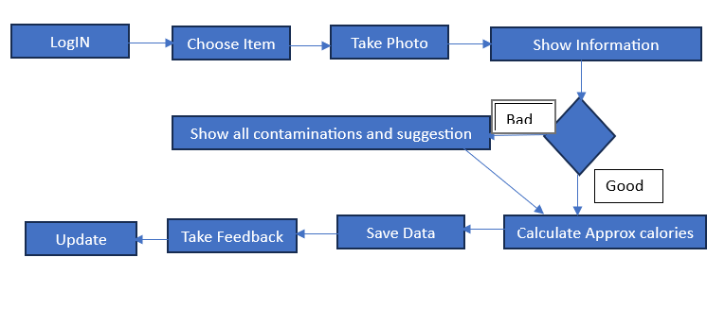

Here are some features that the application will provide:

- Will give an array of options to the users.
- App interface will be easy to access for all ages.
- Will also work without internet for selected options.
- Only a mobile camera will be enough.
- According to users feedback it will update its system.

Ⅴ. Conclusion
In summary, the integration of Artificial Intelligence (AI) in addressing food contamination issues in Bangladesh offers a transformative solution to enhance food safety and protect public health. Through data analysis, predictive modeling, and real-time monitoring, AI technologies have the potential to revolutionize the identification and mitigation of foodborne risks. Embracing AI in the fight against food contamination presents Bangladesh with an opportunity to significantly improve the safety and sustainability of its food supply chain.
References
- Accum FC: A treatise on adulterations of food and culinary poisons: exhibiting the fraudulent sophistications of bread, beer, wine, spirituous liquors, tea, coffee, cream, confectionery, vinegar, mustard, pepper, cheese, olive oil, pickles and other articles employed in domestic economy; and methods of detecting them. J Mallett Sold by Longman Hurst Rees Orme and Brown 1820.
- Irfan A. Rather, Wee Yin Koh2, Woon Kee Paek, Jeongheui Lim (2017) Available at: https://www.frontiersin.org/articles/10.3389/fphar.2017.00830/full

- Ishvarchandra Parmar(2022), RECENT DEVELOPMENT IN FOOD ADULTERATION ANALYTICAL
- https://www.mdpi.com/2673-7256/1/2/8Havva Tumey Tamiz, Berdan Ulas(2021) A Review of Recent Studies Employing Hyperspectral Imaging for the Determination of Food Adulteration
https://www.mdpi.com/2673-7256/1/2/8

- https://www.sciencedirect.com/science/article/abs/pii/S0026265X21001727#:~:text=This%20study%20present%20a%20customer,mobile%20phone%20with%20a%20camera.

Appendix






 

